ADD YOUR SETTING LOGO HERE

Date:

Dear Parent/Carer

Re: 27 Month Integrated Review

Now that is old, it is time for his/her 27 Month Review. This review is offered to all children in Hackney. It gives you the opportunity to ask anything you want to know about your child’s health and development including their learning and behaviour.

The review will take place at your child’s early years setting with a health professional from the local health visiting team. The My Portrait at Two (Progress Check at Two) will also be completed by your child’s key person and following yours’ and the health professional’s contributions it will be placed in your Red Book.

Preparing for the Integrated 27 Month Review

You will receive an Ages and Stages Questionnaire - 3 (ASQ-3) from your child’s Early Years Setting, you must complete this questionnaire before the review meeting. As a parent or caregiver, we know you are the best source of information about your child. The ASQ-3 questionnaire will take only 10-15 minutes to complete, it is that quick and easy!

- Answer each question “yes,” “sometimes,” or “not yet,” based on what you know your child is able to do now, we need your answers to be as accurate as possible so that it shows your child’s strengths and any areas where he/she may need practice.

- Have fun with your child trying the various activities. You can make a note of what you have seen and any questions you may have. If you do not understand a question you can leave it and ask your child’s key worker to explain it/ help you to answer it.

- The completed questionnaire will be discussed at the 27 month Integrated review meeting and the health professional will talk about the outcomes with you.

If your child needs help with some skills or development areas, the health professional and early years setting professional will work with you to agree on the best way to support you and your child. Addressing any issues as early as possible supports young children’s healthy development and helps to prepare them for life at school later on.
By attending this review, you are helping to ensure that your child is off to the best possible start.
Your child’s 27 Month Integrated Review will be on:

Date: Time: Venue:

Therefore, it is very important that you attend this meeting.

You must provide:

Your child’s Red Book and The completed Ages and Stages Questionnaire (returned to your
your child’s nursery at least 1 day before the your meeting)
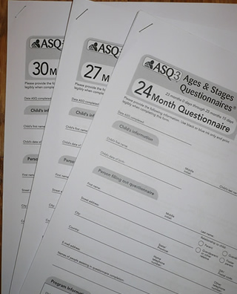



Infection Control/COVID-19 Safety Measures
You will be asked a few questions on entering the early years setting and will also be requested to apply hand sanitiser on arrival and prior to leaving the room.

You must bring to the review meeting:


- A suitable face covering (to cover your nose and mouth) 2. A pen
We look forward to seeing you,

Yours sincerely

Link Health Professional Healthy Child Lead Practitioner

--------------------------------------------------------------------------------------------------------------------------------
The slip must be returned to: by: (date)

Name of parent/carer who will be attending the Integrated 27 Month Review Meeting
Parent/carer name:

N.B. By signing this form you are agreeing to information being shared with a Health Visitor. It will also be used for statistical purposes and may be shared with other professionals. By signing this form, it is deemed that you understand the purpose that the information will be used for.
Signature of parent/carer:

