Key events
Use the dates in the article to complete the timeline below, showing key events during the Dambusters Raid, from earliest to latest.

Event Event Event Event

Date Date Date Date _____________ ______________ ____________ _____________

Summarise: Key people
Make brief notes from the article
Name | Role/ What did they do?
Barnes Wallis
Commander Guy Gibson
???

Before reading the article:
Predict – what do you think this will be about? What do you think you will find out? Do you already know anything?_________________________________________________________________________________________________________________________________________________________________

THE INCREDIBLE STORY OF THE DAMBUSTERS RAID

THE INCREDIBLE STORY OF THE DAMBUSTERS RAID

THE INCREDIBLE STORY OF THE DAMBUSTERS RAID
The Dambusters raid of May 1943 was a British RAF bombing mission that destroyed a number of important German dams. Known as Operation Chastise, the raid is one of the most famous air operations of the Second World War. It was immortalised in the 1955 film The Dambusters. There is an article to read here: https://www.iwm.org.uk/history/the-incredible-story-of-the-dambusters-raid
Completing the sections of this ‘knowledge organiser’ will help you to understand the article and answer the Big Question, on the next page.

While you are reading the article:
Question - do you have any questions?_______________________________________________________________________________________________________________________________________________________________________Clarify – were there any words or phrases that you didn’t understand? ________________________________________________________________________________________________________________________
Summarise: Where and What?
Use brief notes from across the whole of the article
Place/object/event | Description of the object, event, or place and what happened ?
Ruhr valley, the industrial heartland of Germany
Operation Chastise
The three main targets
‘Upkeep’
Squadron X, 617
‘The result’

Try to answer questions by first re-reading or reading ahead; talk to someone else about what you have read; if you are unsure do some research in books or online to see if you can find the answer.

Try to read new words by sounding them out, then re-read or read ahead to see if you can work out what it means; talk to someone else and finally use a dictionary to look up the meaning.

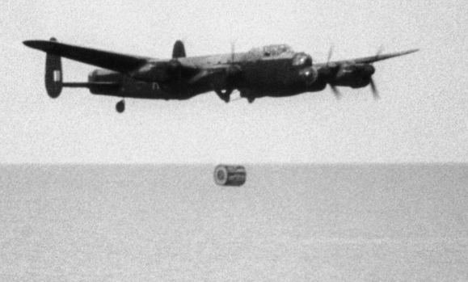
Try to answer the ‘Big Question’:
In your view, was ‘Operation Chastise’ a success? Was the cost in human lives justified?

Make sure you understand the question.
Use, Predict, Question, Clarify,Summarise

For example:
Predict What do you predict the answer to this question might be? Why?

Question Why am I being asked if it was a success or not?

Clarify What was Operation Chastise? You may need to go back to the knowledge organiser.
What does ‘the cost in human lives mean?’

Summarise Try and ask the question in your own words to confirm you understand what it means.

Now, try answering the Big Question. See the next page for some ideas to help you structure your answer.
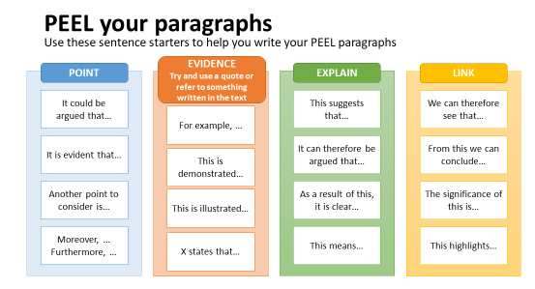
Answering the Big Question
Use POINT, EVIDENCE, EXPLAIN (PEE) or POINT, EVIDENCE, EXPLAIN, LINK (PEEL) to structure your answer. The diagram below gives a useful summary.

